

**Khulna University of Engineering and Technology**

**Department of Mechatronics Engineering**

**Project on files in C Programming**

**Course No:** CSE 1231

**Submitted to:**

**Sourav Roy**  
Assistant Professor  
Department of Mechatronics Engineering  
Khulna University of Engineering & Technology (KUET)  
Khulna -9203, Bangladesh.

**Priyo Nath Roy**  
Lecturer  
Department of Mechatronics Engineering  
Khulna University of Engineering & Technology (KUET)  
Khulna -9203, Bangladesh.

**Submitted by:**

**Name: Shahriar Ferdous**

**Roll:** 1831002

**Year:** 1st

**Semester:** 2nd

**Submission Date: 18-9-2019**

**Problem:** Admission to a professional course is subject to the following condition:

* Marks in mathematics >= 60
* Marks in Physics >= 50
* Marks in chemistry > = 40
* Total in all three subjects >= 200

Or

* Total in mathematics and physics > = 150

Given the marks in the three subjects, write a program to process the applications to list the eligible candidate. (Using files)

Write the code for ten applicants.

**Solution:**

* First a program in c language is written to take the inputs from the user and store it in a .txt file named “marks.txt” from where further process will be done. The input is the marks of these three subjects of ten students.

**First code:**

#include <stdio.h>

int main()

{

FILE *in;

char math[10], phy[10], ch[10], st[10];

in = fopen ("C:\\Users\\Lenovo\\Desktop\\UV\\cse assignment\\marks.txt", "w");

printf ("Total students: 10\n\n");

for (int i=1; i<=10; i++) {

printf ("Student_NO: %d\n", i);

printf("Enter marks: \n");

printf ("Math: ");

scanf ("%s", &math);

printf ("Physics: ");

scanf ("%s", &phy);

printf ("Chemistry: ");

scanf ("%s", &ch);

printf ("\n");

fprintf(in, "Student_NO: %d\n", i);

fprintf(in, "Math: %s\n", math);

fprintf(in, "Physics: %s\n", phy);

fprintf(in, "Chemistry: %s\n", ch);

fprintf (in, "\n");

}

fclose (in);

return 0;

}

**Output:**

|  |  |
| --- | --- |
|  |  |

Fig: Taking inputs in program Fig: Inputs preserved in a .txt file

* Then the second program will take inputs directly from that “marks.txt” file where the marks are saved and will process those marks. Than it will show weather those ten students are eligible or not accordion to the given conditions.

**Second Code:**

#include <stdio.h>

int main()

{

FILE *input;

char sub1[80], sub2[80], sub3[80], line_1[80], line_2[80],

line_3[80], line_4[80], c[80], blank_line[80];

int num, math, phy, ch;

input = fopen("C:\\Users\\Lenovo\\Desktop\\UV\\cse assignment\\marks.txt", "r");

printf ("Total Student: 10\n\n");

for (int i=0; i<10; i++) {

fgets(line_1, 80, input);

fgets(line_2, 80, input);

fgets(line_3, 80, input);

fgets(line_4, 80, input);

fgets(blank_line, 80, input);

sscanf (line_1, "%s %d", &c, &num);

sscanf (line_2, "%s %d", &sub1, &math);

sscanf (line_3, "%s %d", &sub2, &phy);

sscanf (line_4, "%s %d", &sub3, &ch);

if (math >= 60 && phy >= 50 && ch >= 40 && math+phy+ch>=200)

printf ("%s is Eligible\n", line_1);

else if (math + phy >= 150)

printf ("%s is Eligible\n", line_1);

else

printf ("%s is NOT Eligible\n", line_1);

}

fclose(input);

return 0;

}

**Output:**

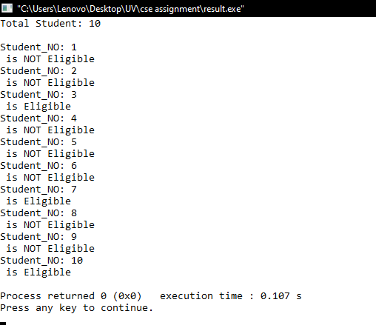

Fig: Eligibility result of following ten students